CMU ROBOT AUTONOMY PLUS HW1  
David Wong

_______________________________________________________________

**Q1-3**

Pdes = (10 + 0.14*9.81 + PID_D * prevError * dt) / PID_P

Impedence control gains:  
P 150   
I 0   
D 2

Force control gains:  
P 0.05  
I 5  
D 0

**Q4**Beta angle = 30deg

Force controller maintains at 10N force and can compensate for disturbances.

Impedance controller unable to reach set point therefore unable to compensate unless constrained to a single axis.

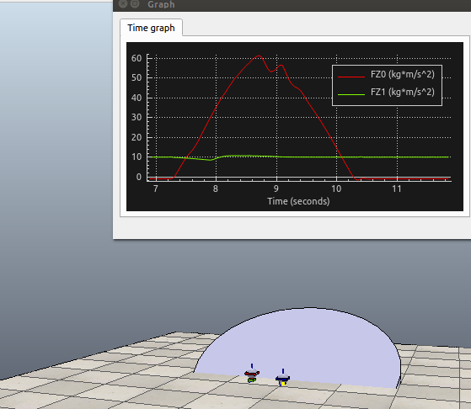

**Q5 (FK)**('computed FK ee position', array

([ 5.17025000e-01, 1.00000000e-04, 4.19326800e-01]))

('computed FK ee rotation', array

([[ 1., 0., 0.],

[ 0., 1., 0.],

[ 0., 0., 1.]]))

('computed FK ee position', array([ 0.34547502, -0.25488326, 0.3462286 ]))

('computed FK ee rotation', array

([[ 0.66446302, 0.4166168 , -0.62041867],

[-0.66446302, -0.0505914 , -0.74560673],

[-0.34202014, 0.90767337, 0.24321035]]))

('computed FK ee position', array([ 0.55687573, 0.26545164, 0.18333242]))

('computed FK ee rotation', array(

[[ 0.66341395, -0.5 , 0.5566704 ],

[ 0.38302222, 0.8660254 , 0.3213938 ],

[-0.64278761, 0. , 0.76604444]]))

**Q6 (IK)**

('error', [-0.00025421610098685932, 0.00077899214378802321, -0.00046139698293351517, 0.0017073247292268372, -0.00019739614298478077, -0.00030372887510463146])

('compute IK angles', [-0.013156957715076906, 0.098617762550962634, 0.40208545828889614, -0.14120272766487516, 2.0615201361756124])